Lab Assignment #5
Cryptography

Steffen L. Norgren <ironix@trollop.org>
A00683006

COMP 7615 • BCIT • November 16, 2009

Table of Contents
Purpose 3
Procedures 4
1. Using RSA with CrypTool 4
2. RSA Implementation 6
3. Hybrid Cipher 12
Discussion 17
1. Using RSA with CrypTool 17
2. RSA Implementation 17
3. Hybrid Cipher 18
Conclusion 18

Purpose
To better understand the process of RSA encryption and decryption as well as the effect of using different random number and key values for encryption using RSA. Additionally, we observe the process of RSA-AES encryption and decryption using a public key.

Procedures

1. Using RSA with CrypTool
Example encryption using small values for p and q.
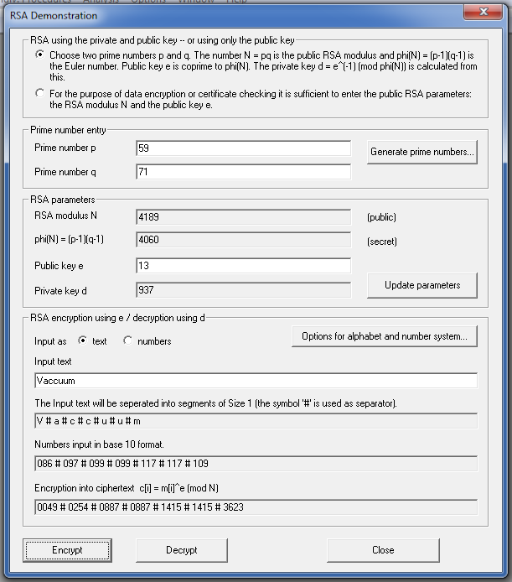

Changing the values of p and q to larger three digit values.
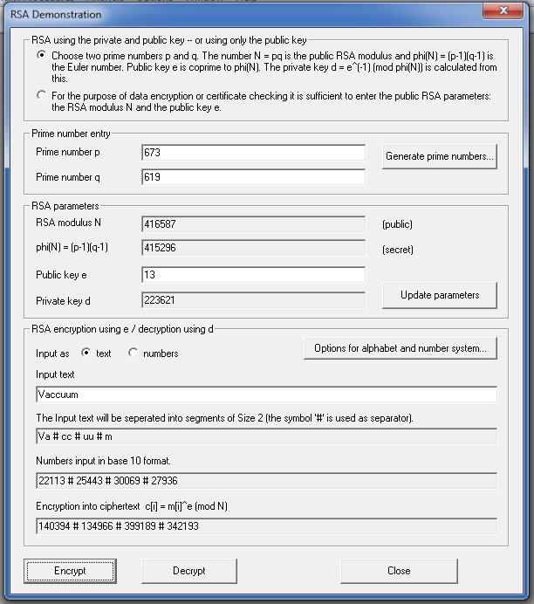

2. RSA Implementation
Creating an asymmetric key.
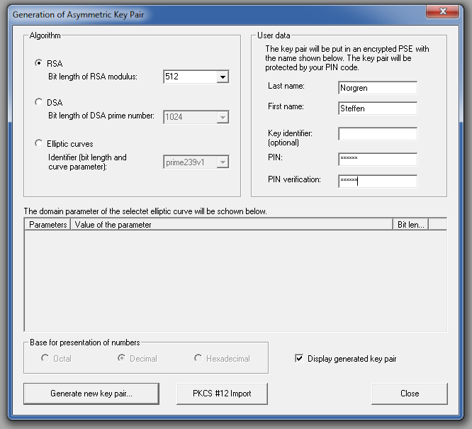
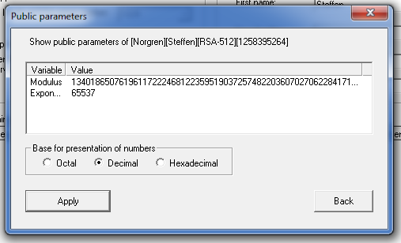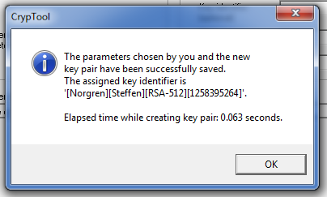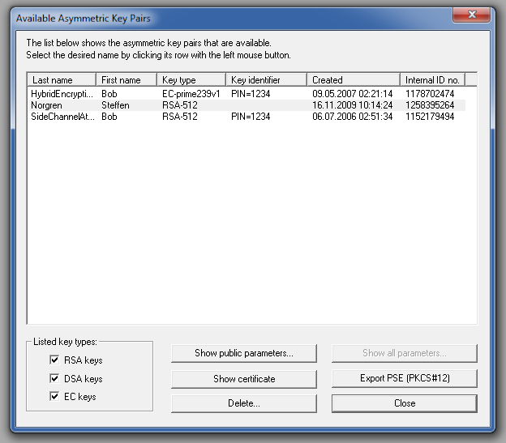
Now we create a small text to use for encryption using the key we just created.
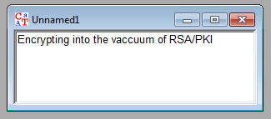

And then we encrypt the above text using RSA encryption and our newly created key.
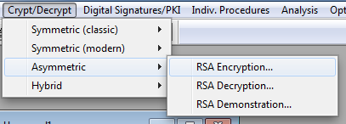
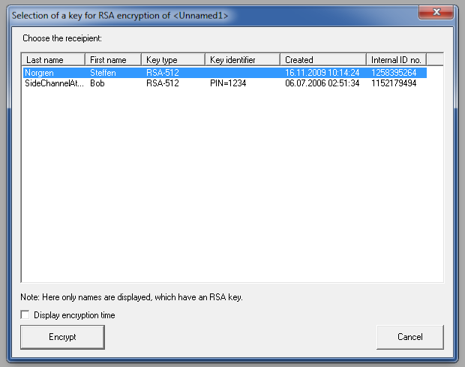

This results in the following encrypted text:
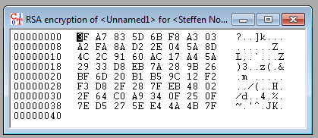
Which we will then decrypt using our previously created key.
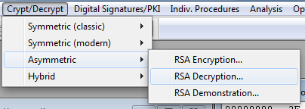
We have to enter the PIN code we used when creating the key, then we can decrypt.
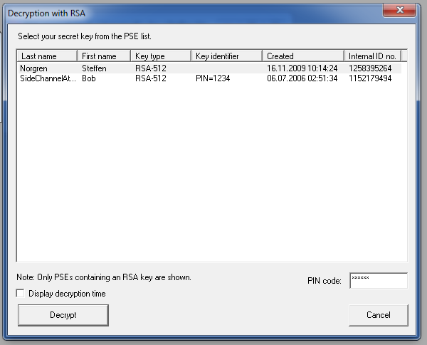
The newly decrypted text as HEX:
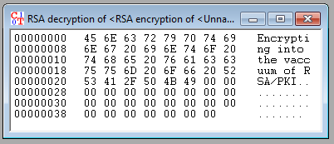

And as plain text:
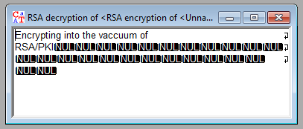

3. Hybrid Cipher
Encrypting a file using the RSA-AES hybrid cipher.
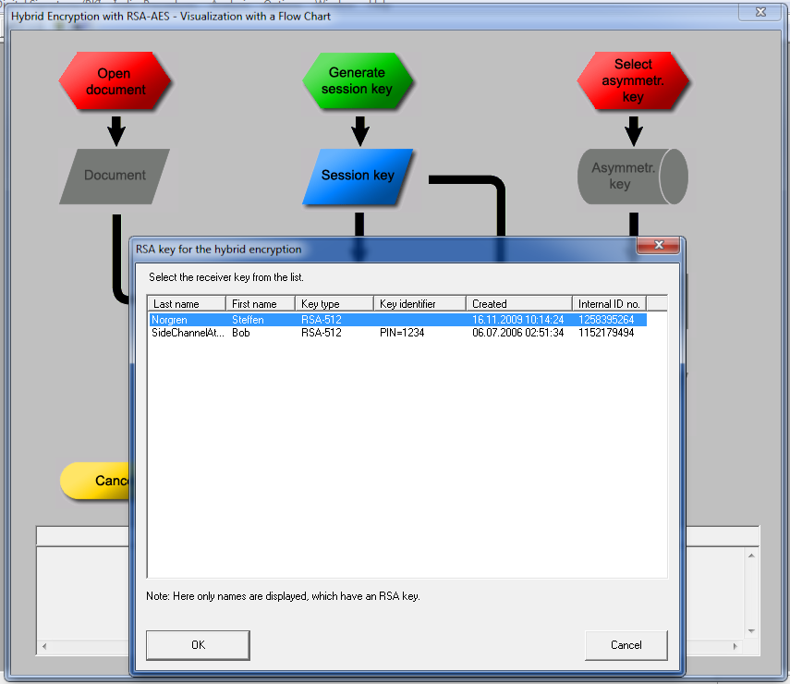
The newly encrypted text:
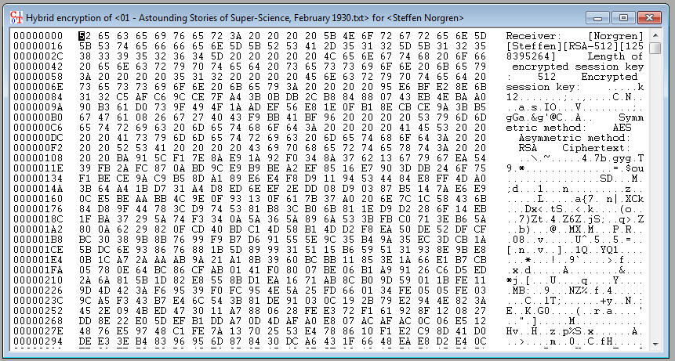
Now we can decrypt the encrypted file, but again, we have to input our PIN.
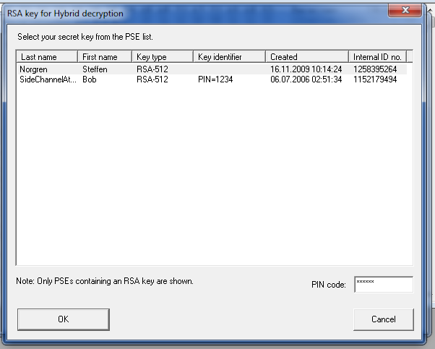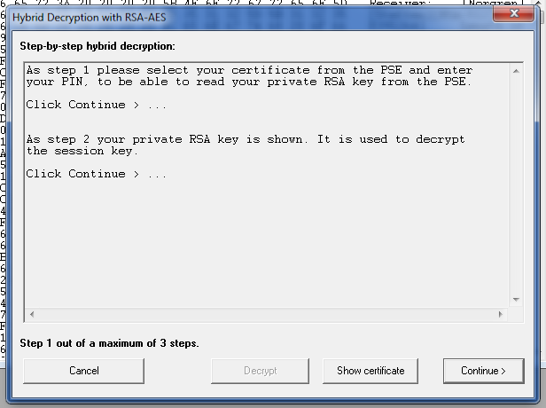
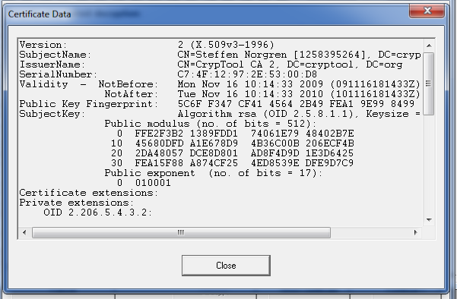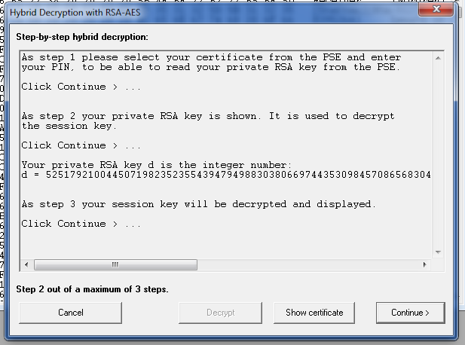
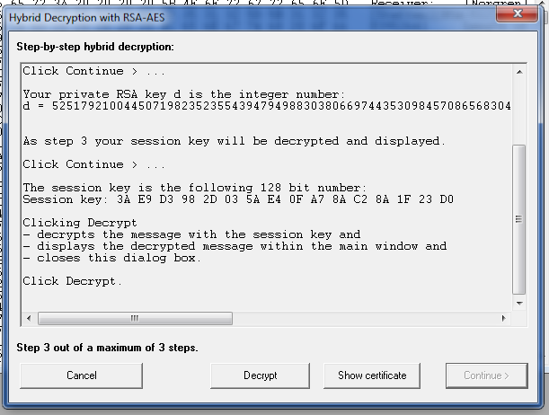
And this results in a properly decrypted text:
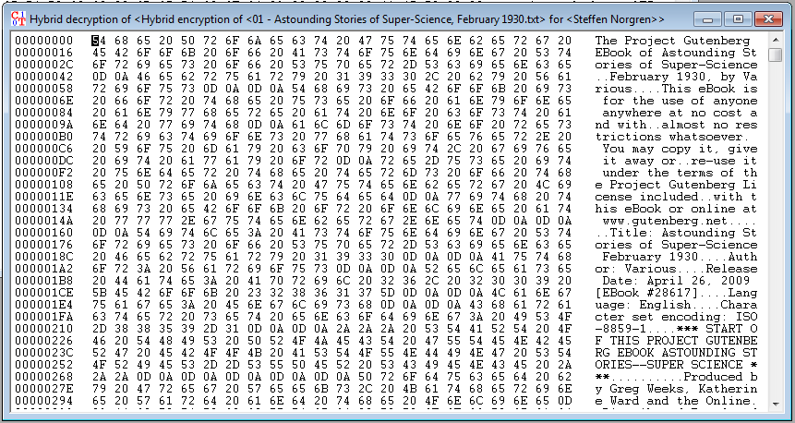
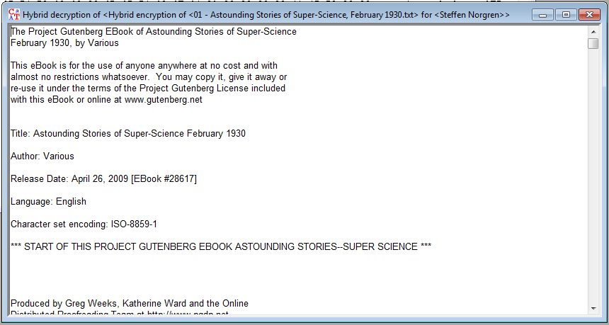

Discussion

1. Using RSA with CrypTool
When using a small value for p and q, our text is separated into single character blocks for encryption. When using a text with repetitive characters, such as 'vaccuum', these encrypted blocks end up having the same value. If we were to encrypt a large text using suck small values for p and q, a cryptanalyst could easily decrypt the text by doing a simple frequency analysis for blocks of values.
However, upon making use of larger values of p and q, we can use larger blocks of text for encryption, decreasing the chance of there being any repeating values susceptible to pattern analysis.

2. RSA Implementation
In the RSA example we create a key that creates its own random values of p and q as well as the key itself. Because of this, we end up with much later blocks of text that are encrypted, even further reducing the possibility for any easy cryptanalysis. To decrypt the data we need to use the same key, but we need to enter our PIN to decrypt the data, making it more difficult for someone to simply steal your private key to decrypt your files.
However, if one were to gain access to your private key, it would still be susceptible to a brute force password attack, so your key, no matter how many bits it is, will only be as secure as the password you chose.

3. Hybrid Cipher
In the hybrid cipher, the key used to encrypt the file is actually encrypted itself using a random session key that is generated on demand.

Conclusion
Throughout the procedures of this lab we have been shown several methods of advanced encryption and how some implementations have weaknesses depending on the random values of p and q when doing the initial encryption. We have been shown that the larger the value of p and q, the larger the blocks of text that get encrypted, thereby reducing the changes of any type of frequency analysis being performed to decrypt the text.
Additionally, we can increase the key security by encrypting the key with a random session key before using it to encrypt the file and therefore we would be sending the new encrypted key to the recipient as the public key. As a result, even if the file could be decrypted though a brute force attack, the original key used wouldn’t be compromised.

